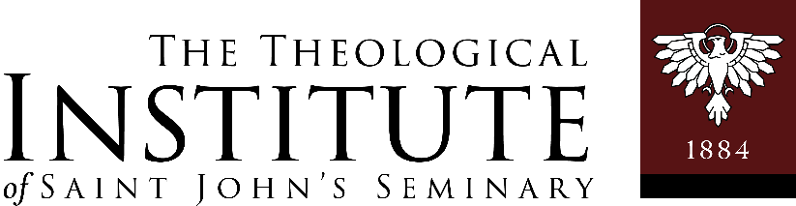

FORMATION THROUGH APOSTOLIC FORMATION
ANSWERS TO FREQUENTLY ASKED QUESTIONS

Master of Arts in Ministry Program – Saint John’s Seminary
Rev. Frank Silva, Coordinator of Pastoral Formation
Phone: 617.746.5425 Email: frank.silva@sjs.edu

● All students are asked to seek guidance, in extended prayer, from the Lord for her / his field education component of the M.A.M. degree.

● All assignments for field education need to be arranged through the Director of Pastoral Formation. Before a field education experience begins the student, with his or her supervisor, completes the Learning Plan and discusses it with the Coordinator of Pastoral Formation for feedback.
The student then maintains a Field Education folder of all their paperwork.

● All field education assignments include an on-site supervisor; supervision in its whole sense and not merely by distant mentorship. On-site refers to one who has responsibility and oversight for the particular ministerial work and is a member of or liaison to the staff of that institution or organization. Supervisors must be practicing Catholics who reflect the teaching of the Catholic Faith.

● Informal supervision discussion happens frequently during the course of the placement. A student meets with her/his supervisor twice a month for a formal, forty-five minute, supervision meeting. One of those meetings uses the Supervision Reflection Guide as a tool to focus the feedback and learning.
Monthly, a completed copy of that Supervision Reflection Guide is emailed by the end of each month to:
Ellen T. Oesterle, Administrator of TI, (email) ellen.oesterle@sjs.edu.

● 4 semesters are required of field education, each 3 credits per semester, on a basis of 100 hours of direct service per academic year for two distinct placements. This is arranged to include a minimum of four hours per week of on-site supervised learning during an academic year. For optimal formation each 100 hours of field education must be completed in the length of a typical academic year – nine months. At the completion of the field education experience the supervisor initials the Final Assessment indicating that 100 hours of service has been satisfactorily completed and sends to the Coordinator of Pastoral Formation, via the TI Assistant to the Director.

● The seriousness accorded to an academic course must be given to the learning and formation received from a field education experience. A grade of incomplete will be given if the 100 hours of learning is not completed within the period of an academic year – nine months, and the student has one additional semester to receive a passing grade.

● Field Education involves placement in ministerial service that is non-compensatory (not part of your regular employment). Special Field Education projects in the area of your employment can be arranged if they are not part of your employment contract and remain not for compensation or hire. The Field Education Supervisor must be different than the immediate supervisor for employment.

● To assure an integrated learning experience, no retroactive credit can be given for field education experiences not related and arranged through this Master of Arts in Ministry program. Additionally, each year of the two years of Field Education must be distinctly different placements and different supervisors.

● In order to assist the student in deepening theological understanding of particular ministerial experiences each student is required to attend and prepare a written theological reflection paper, of no more than two pages, for the two Evenings of Theological Reflection. A Progress Report must be completed by the student and supervisor at the end of the first semester (to receive three full credits) and a Final Assessment must be completed as well in order to receive full credit and completion of the program.
All M.A.M. Field Education Documentation is to be forwarded to (email): ellen.oesterle@sjs.edu.

