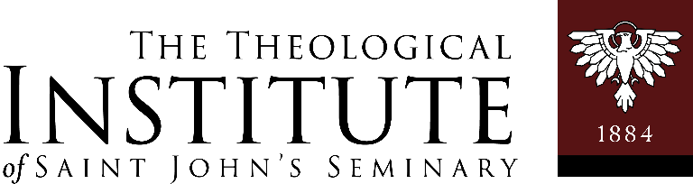

PROGRESS REPORT

Master of Arts in Ministry – Saint John’s Seminary
Rev. Frank Silva, Coordinator of Pastoral Formation
Phone: 617.746.5425

E-mail: ellen.oesterle@sjs.edu (Administrator of The Theological Institute)
Due: Friday, December 4th, 2026

Student: ________________________________________________________________

Supervisor: _____________________________________________________________

Placement: ______________________________________________________________

I. FOR THE STUDENT - Briefly assess the following:

- How did you prepare for your pastoral assignment each week?

- What are some of the challenges you faced in meeting the expectations of your assignment?

- In light of your Learning Plan, what were some of the goals you accomplished?

- Were there any additional learnings not envisioned in your original Learning Plan?

- What were some of the challenges you faced as you worked to integrate the four aspects of formation?
(I.e. Human, Intellectual, Spiritual and Apostolic)

(continued on next page)

II. FOR THE SUPERVISOR - Briefly assess the following:

- What were some of the student’s principal accomplishments during this semester?

- What areas should the student give more attention to for increased growth?

- Please note any adjustments to the Learning Plan or additional areas of Formation you foresee will assist the student to experience the most in this placement.

Please check one:

□ Exceeds Expectations

□ Meets Expectations

□ Does Not Meet Expectations

Please sign below.

Student: ________________________________________________Date: ____________

Supervisor: _____________________________________________ Date: ____________

Coordinator of Pastoral Formation: ________________________ Date: ____________

